

FortnaPlus Control
Advanced Search Feature
Document Revision: 1.1
Date: 26-Jul-2022

Revision | Date | Author | Revision Summary
1.0 | 03-Nov-2014 | B C Conklin | New document
1.1 | 26-Jul-2022 | T R Kremser | Update and general refresh

Table of Contents
1. Section 4
2. Section 4
3. Section 4

Confidential/Proprietary Statement
This document contains trade secrets and information that is considered confidential and proprietary to Fortna, Inc. It may not be duplicated, used, or disclosed outside the original recipient organization, and it may not be duplicated, in whole or in part, for any purpose other than to evaluate this document. Fortna Material Handling reserves the right to modify this document as necessary to reflect any terms and conditions negotiated and included as part of a subsequent contract or purchase order.

Glossary of Terms
AC – Automation Controller
FPC – FortnaPlus Control
UPS – Uninterruptible Power Supply

FPC Table Types
FortnaPlus has two distinct table types based on where the data is stored. For most purposes, this distinction does not matter, but when using the search features, it is important to understand the difference. In-memory tables are searched using C-language string comparisons. Database tables are searched using SQL queries. In-memory tables will always show all records, with each “find” operation taking you to the next matching row. Database table searches will show only the rows that match. Database tables will potentially contain data from all ACs in the system, not just the local AC, unlike in-memory tables.
Most of the tables in FPC are in-memory tables, so it is easier to list the database tables:
DbHistConfig, DBHistData -- Associated with the Scanner Statistics Display feature.
Error_Log – System-wide error information. Only directly accessible from F2-MenuOfMenus (F10-0 table ErrorStatus is an in-memory table, though they contain similar data).
ErrorCustom1, ErrorCustom2 – Seldom used. If used, usually defined to extract data from table Error_Log.
ErrorStatusLog – F10-1. Based on data from the Error_Log table.
ErrorAnalysis – F10-2. Based on data from the Error_Log table.
EventLog – System-wide events. Accessible from the Operator Menu.
FPLOrLane, HostDataImport – Tables used by the Fortna Lite feature (O’Reilly).
Password – System-wide FPC user login and password information.
TimeList – This table reports the state of the FPC timers. Not used within FPC. Not to be confused with table timemenu, the in-memory table that defines the FPC timers.
MsgTrack, Scanners, System_Status – No longer used.
All other tables are in-memory tables.

Searching FPC Tables
FPC tables have a Search dialog box that you can access using the  icon in the upper left corner of the table. The Search dialog looks like this:
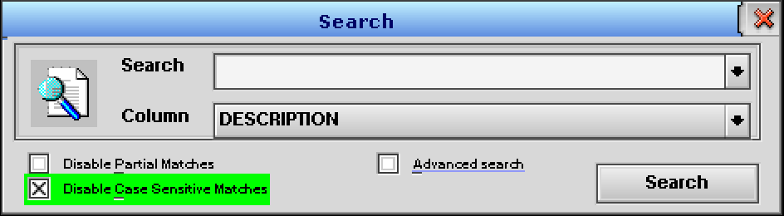

For basic search capabilities, make sure Advanced search is not selected and enter a search string into the Search box. Choose the column you wish to search from the pull-down list in the Column box. Click the Search button.
When searching in-memory tables, the entire contents of the table will always be displayed, but the cursor will jump to the first row with a match. The button text will change to Find next. Each subsequent click will move the cursor to the next matching row. When the end of the table is reached, the next click of Find next will wrap the cursor around to the first matching row again. If no match is found, an error dialog is displayed, such as: “Can’t find ‘FOO’ in the ‘DESCRIPTION’ column”.
When searching database tables, once you begin the search, only the matching rows will be displayed. An additional icon will appear in the upper-right corner of the table, just below the . To end the search and restore the display to show all rows in the table, click the  icon. You can change the Search string and re-run the search as needed as long as the dialog box is open. The search results will be displayed even after the search dialog box has been closed, so always look for the  icon!
You can control how the search is done using the three checkbox fields:
If Disable Partial Matches is selected, your search string must match the entire contents of the field. When not selected, a match will be found if the search string appears anywhere in the field. By default, Disable Partial Matches is not selected.
If Disable Case Sensitive Matches is selected, the comparison will be made without regard to case. When not selected, it must match the case exactly. Disable Case Sensitive Matches is selected by default.
The settings for these three checkboxes are retained until FPC is shut down. The default settings will be restored at startup to the settings shown in the image, above. The settings are universal – one set for all tables.
The remainder of this document describes how to search using the Advanced search feature.

Advanced Search Weirdness
Unfortunately, the Advanced Search feature has some strange quirks, though it does allow more elaborate conditions to be applied.
As with the simple search, you must be aware of the type of table you are searching, but is even more important here, which will likely lead to a great deal of frustration. The search syntax for the two types is very different. Without the above list of database-based tables, it will be hard to know which syntax to use. I suggest you perform a simple search first and look for the presence or absence of the  icon to determine which type of table you are searching.

Once you know the type of the table you wish to search, read the appropriate section, below, for the proper syntax and procedure.
Alternatively, it may be less frustrating and more productive to try one of these methods outside of FPC to perform advanced searches instead:
For in-memory tables: Search the underlying files with QNX command-line commands. Use the grep command in /SortPlus/RUN, /SortPlus/RUN/FORTNA and/or /SortPlus/RUN/PROJECT to search the entire set of configuration files. Be sure to save data first so the latest information is written to those files. You could also use the saveallfortna command from the command line to accomplish the same thing, though that command saves data on all ACs, not just the one you run the command from. Other documents describe the details and subtleties of grep, awk, sed, and find commands, but it can be well worth your effort to learn. One of the biggest benefits is to be able to easily save your search results to a file.
For database tables: Query the MySQL database directly. The Advanced Search option uses SQL syntax, so you need to know it either way. Some basic SQL is described in this document, but other documents and web resources are more complete. Extracting the data from database tables directly using MySQL is more efficient, can be done “from the back”, and also makes it easy to save the results to a file.
If you are brave, and would like to forge ahead with the Advanced Search feature, read on…

Searching Memory-Based Tables
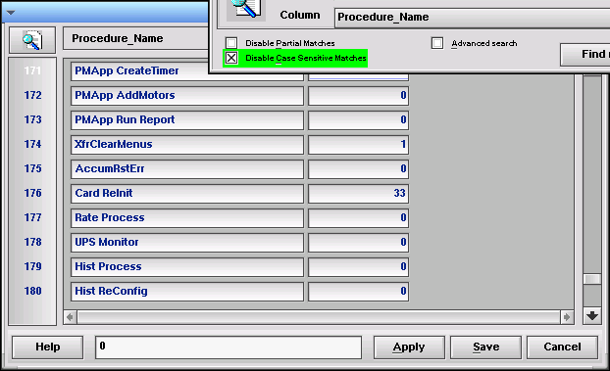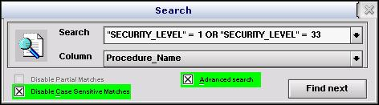
Select the Advanced Search option in the Search dialog box.
In this mode, you must compose the search command in the Search box. The search command can be a compound logical statement using simple comparison statements joined with AND or OR to search multiple columns or multiple conditions at the same time. You can use the following features to compose your search request:
Operators:
- = – The data must match exactly. Works for numbers and strings.
- != – The data does not match. Works for numbers and strings.
- > –Greater than. For use with numeric values.
- >= – Greater or equal. For use with numeric values.
- < – Less than. For use with numeric values.
- <= – Less or equal. For use with numeric values.
- LIKE – String partial match. For strings only.
Key Words:
- AND – Combine simple comparisons where all must be true for a match to be found.
- OR – Combine simple comparisons where any can be true for a match to be found.
To enter a column name, select it from the drop-down list. Its name will be inserted in the Search box, wrapped with double-quotes, which are required.
When entering your string search criteria, wrap them in single-quotes – double-quotes will not work! Do not use quotes for numbers!
NOTE: Column names REQUIRE double-quotes. Operators and Keywords MUST have at least a single space on either side. Numbers CANNOT be quoted or they will be compared as though they were strings and you will not get the result you expect! Strings with no spaces do not require single-quotes, but you are encouraged to use them for all strings, because strings with spaces REQUIRE single quotes. You cannot use parenthesis for grouping, so be careful with the order of your AND and OR statements, as they will be evaluated from left to right.
(The double-quote/single-quote thing is super weird and needs to be fixed (I didn’t create this one!), but wait, it gets worse when you get to the database tables – TRK)
NOTE: The drop-down for the Search box retains your recent searches on a per-table basis. Calling back a search that way can save a lot of time.
Searching memory-based tables with the Advanced Search option is similar to the basic option in that all the rows in the table continue to be displayed, and the Search button text will change to Find next. The search will wrap around after the last item is found.
When you close the search dialog box, the search is ended. All rows are always displayed.
Example: Search the Set Security Levels table (Administration Menu | Set Security Levels) for a Procedure_Name with the strings “Move” or “Disp”. The image shows the Search dialog and the table with the cursor on the third matching row. See if you can find the first two matches.
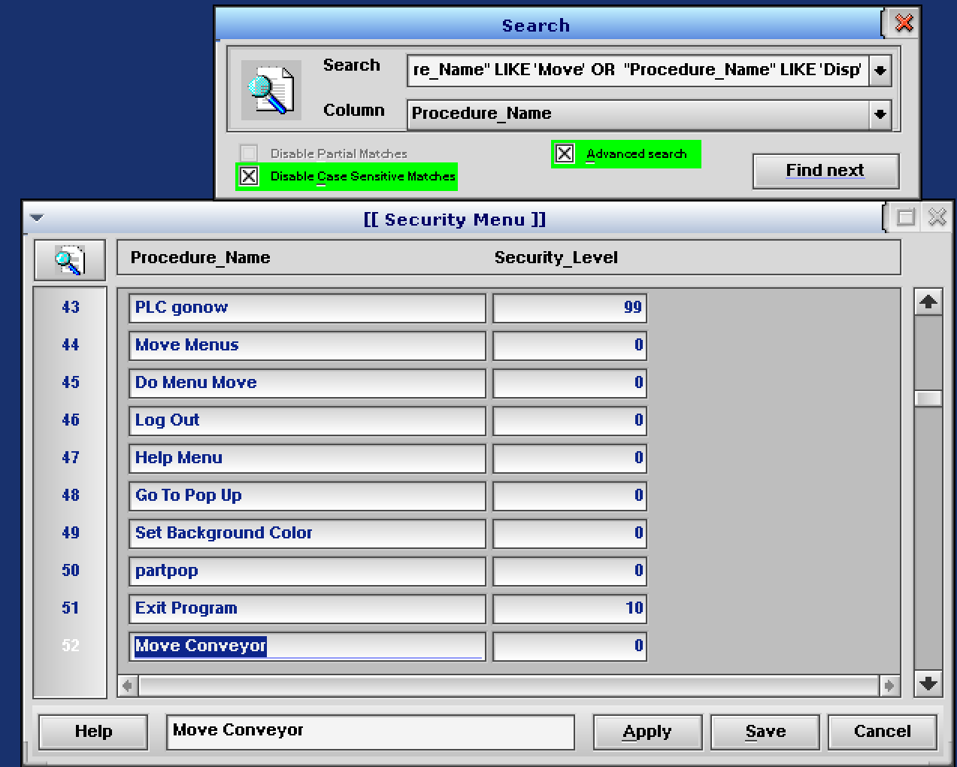

  - Disable Partial Matches is automatically de-selected in Advanced Search mode.
  - Select the Disable Case Sensitive Matches box.
  - Select the Advanced Search box.
  - Enter “Procedure_Name” LIKE ‘Move’ OR “Procedure_Name” LIKE ‘Disp’ into the Search Field. LIKE always searches for a substring anywhere in the string. All characters in the search string are interpreted literally – do NOT use *, . (dot), % or _ for wildcard matches, or ^ or $ for begin / end matching!

Searching Database Tables
Select the Advanced Search option in the Search dialog box.
In this mode, you must compose the search command in the Search box. The search command can be a compound logical statement using simple comparison statements joined with AND or OR to search multiple columns or multiple conditions at the same time.
AND, OR and the Operators are the same as defined for the memory-based searches, except the LIKE operator REQUIRES use of wildcard characters (I told you it gets worse!). Numeric values CAN BE quoted with single quotes and will still match as expected. Parenthesis work as expected and are encouraged to ensure proper logical evaluation.
Column names MUST NOT be quoted! (Frustrated yet?)
Database tables display the  icon in the upper right of the table, below the  while an active search is in effect, and all displayed rows will match the criteria. You can alter the search criteria and click Search again to run a new search. To clear the search and display all records, click the  icon. The “Search” button will not change to “Find Next” as it does for in-memory tables.
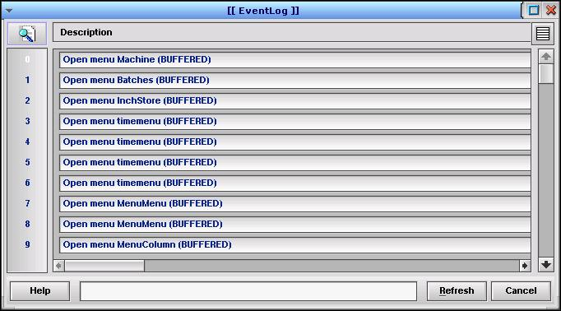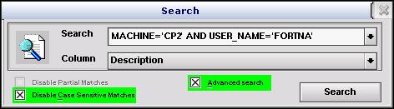
Indicates a database search view is active. Click the icon to exit the search and restore display of all rows. The icon will also disappear.
Example: Search the EventLog (database) table for all rows associated with Machine ‘CP2’ and User_Name ‘fortna’. The image above shows the search dialog that goes with this example.
  - Disable Partial Matches is automatically de-selected in Advance Search mode.
  - Select the Disable Case Sensitive Matches box.
  - Select the Advanced Search box.
  - Enter Machine=’CP2’ AND User_Name=’fortna’ into the Search box.
NOTE: For database tables, the column name must NOT be quoted. SQL wildcards are REQUIRED for partial string matches with LIKE. The % (percent) character matches zero or more characters. The _ (underscore) character matches any single character.
NOTE: The drop-down for the Search box retains your recent searches on a per-table basis. Calling back a search that way can save a lot of time. Calling back an Advanced Search item will automatically assert Advanced Search mode. You must turn that mode off manually to go back to simple search mode.
NOTE: You can clear an active search and see all the rows while the Search dialog is still open. Clicking the Search button will re-activate the search and make the icon re-appear. Don’t be fooled into thinking the search is active just because the Search dialog is open! Likewise, the last search for database-based tables will remain active even if the Search dialog box is closed! Always look for the  icon!

